Smart Ping Pong Ball Machine

Status

/1 Hardware present?

/1 Title Page

/1 Declaration of Joint Authorship

/1 Proposal (500 words)

|  |
| --- |
|  |
|  |

/1 Executive Summary

From: Name – Shubham Sharma

Discipline: Computer Engineering Technology

Date: 14 January, 2020

# Declaration of Joint Authorship

We, Gurwarris Singh Sohi, Nicolas Cristiano, and Shubham Sharma, confirm that this work submitted is the joint work of our group and is expressed our own words. Any uses made within it of the works of any other author, in any form (ideas, equations, figures, texts, tables, programs), are properly acknowledged at the point of use. A list of the references used is included. The work breakdown is as follows: Each of us provided functioning, documented hardware for a sensor or effector. Gurwarris provided the functioning for a TB6621FNG Dual Motor Driver. Nicolas Cristiano provided the functioning for a SG90 micro Servo Motor. Shubham sharma provided functioning for ROB11015 Solenoid . In the integration effort Nicolas Cristiano is the lead for further development of our mobile application, Gurwarris Sohi is the lead for the Hardware, and Shubham Sharma is the lead for connecting the two via the Database.

# Proposal

We have created a mobile application, worked with databases, completed a software engineering course, and prototyped a small embedded system with a custom PCB as well as an enclosure (3D printed/laser cut). Our Internet of Things (IoT) capstone project uses a distributed computing model of a smart phone application, a database accessible via the internet, an enterprise wireless (capable of storing certificates) connected embedded system prototype with a custom PCB as well as an enclosure (3D printed/laser cut), and are documented via this technical report targeting OACETT certification guidelines.

Intended project key component descriptions and part numbers  
Development platform: Raspberry Pi 4 B+  
Servo Motor SG90: Used to adjust the horizontal rotation of the ping-pong machine  
TB6621FNG Motor Driver: Used to adjust the launch speed of the machine in addition to its vertical launch properties  
ROB 11015 5V Pull Solenoid: Used to control the time interval between balls launching

We will continue to develop skills to configure operating systems, networks, and embedded systems using these key components to cooperate with one another so they can be integrated into a fully functional ping-pong machine in addition to the ping-pong Smartphone application.

Our application will contain several play options to optimize the amount of success the player will have in being able to develop their skills, including adjustable difficulty, launch interval and horizontal launch. The application will also allow the user to save and access the user’s settings from the last 30 play sessions. These settings are stored into the application’s database after each session has ended.

During the play session, when the ball enters the machine, the solenoid will pull in the ball for however long the user has set the time interval for. Once the ball has launched, it will be able to get launched horizontally within a 180 degree radius, while the difficulty will determine the ball’s launch speed and elevation.

Our project description/specifications will be reviewed by Sebastien Dwornik, ideally an employer in a position to potentially hire once we graduate. They will also ideally attend the ICT Capstone Expo to see the outcome and be eligible to apply for NSERC funded extension projects. This typically means that they are from a Canadian company that has been revenue generating for a minimum of two years and have a minimum of two full time employees.

The small physical prototypes that we build are to be small and safe enough to be brought to class every week as well as be worked on at home. In alignment with the space below the tray in the Humber North Campus Electronics Parts kit the overall project maximum dimensions are 12 13/16" x 6" x 2 7/8" = 32.5cm x 15.25cm x 7.25cm.

Keeping safety and Z462 in mind, the highest AC voltage that will be used is 16Vrms from a wall adapter from which +/- 15V or as high as 45 VDC can be obtained. Maximum power consumption will not exceed 20 Watts. We are working with prototypes and that prototypes are not to be left powered unattended despite the connectivity that we develop.

# Executive Summary

Our team has worked towards, creating an affordable and competitive Ping Pong Ball machine. This project was started with comparing the various Ping Pong Ball machines in the market currently. The common observation was that the machines present in the market right now are either too expensive or don’t give you much competitive play features. Our Smart Ping Pong ball machine will incorporate a feasible product that allows a user to play at various difficulties, with the new smart features like database and statistic support and be controlled by an app run on any android device. This machine will achieve complex play settings using minimal and cheaper hardware but, also using smart and intricate firmware. Using less and cheaper hardware allows us to keep the cost down, and compete with currently sold machines in the market. To make manufacturing easier, we can sell the product in the form an assembly kit to keep the manufacturing costs low. Even if, the cost is low, this product can compete with the most competitive and expensive products in the market.

Contents

Declaration of Joint Authorship 3

Proposal 5

Executive Summary 7

List of Figures 11

1.0 Introduction 13

1.1 Scope and Requirements 13

2.0 Background 15

3.0 Methodology 17

3.1 Required Resources 17

3.1.1 Parts, Components, Materials 17

3.1.2 Manufacturing 17

3.1.3 Tools and Facilities 17

3.1.4 Shipping, duty, taxes 17

3.1.5 Time expenditure 17

3.2 Development Platform 17

3.2.1 Mobile Application 17

3.2.2 Image/firmware 19

3.2.3 Breadboard/Independent PCBs 19

3.2.4 Printed Circuit Board 21

3.2.5 Enclosure 22

3.3 Integration 23

3.3.1 Enterprise Wireless Connectivity 24

3.3.2 Database Configuration 24

3.3.3 Security 24

3.3.4 Testing 24

4.0 Results and Discussions 25

5.0 Conclusions 27

6.0 References 29

7.0 Appendix 31

7.1 Firmware code 31

7.2 Application code 31

# List of Figures

Figure 1. By Android Studio - https://developer.android.com/studio/, CC BY-SA 4.0, https://commons.wikimedia.org/w/index.php?curid=74094999 19

Figure 2. Initial schematic. This work is a derivative of "http://fritzing.org/parts/" by Fritzing, used under CC:BY-SA 3.0. 20

Figure 3. This work is a derivative of "http://fritzing.org/parts/" by Fritzing, used under CC:BY-SA 3.0. 20

Figure 4. Breadboard prototype. 21

Figure 5. PCB design This work is a derivative of "http://fritzing.org/parts/" by Fritzing, used under CC:BY-SA 3.0. 22

Figure 6. Humber Sense Hat Prototype PCB. 22

Figure 7. Example enclosure. 23

# 1.0 Introduction

Idea. Self-driving cars using Machine Learning. Scope and Requirements specification. Project Schedule.

## 1.1 Scope and Requirements

Describe what will be done. It is an Internet of Things (IoT) capstone project that uses a distributed computing model of a smart phone application, a database accessible via the internet, an enterprise wireless (capable of storing certificates) connected embedded system prototype with a custom PCB as well as an enclosure (3D printed/lasercut), and is documented via an OACETT certification acceptable technical report. Also describe the limits of the project and what will not be done (CSA testing) in this project. Include the development platform specifications and any other hardware specifications possibly organized in point form, the Android device requirements, and database specifications/protocols.

Report

/1 Hardware present?

/1 Introduction (500 words)

/1 Scope and Requirements

/1 Background (500 words)

/1 References

# 2.0 Background

We would like to thank mentor Diego Magalhães from AWS for supporting this project. This section is to include at least three references, here is an example of an APA citation of a website (OACETT, 2017) followed by a sentence citing an Article in a Periodical, a Book, and a Journal Article. Humber is planning to host an internal DeepRacer event using an existing example of machine learning (Robuck, 2018), artificial intelligence (Media, O., 2019), and internet connected servers (Kinsella, 2019).

# 3.0 Methodology

## 3.1 Required Resources

Report

/1 Parts/components/materials (500 words)

/1 PCB, case (500 words)

/1 Tools, facilities (500 words)

/1 Shipping, duty, taxes (250 words)

/1 Working time versus lead time (250 words)

### 3.1.1 Parts, Components, Materials

### 3.1.2 Manufacturing

### 3.1.3 Tools and Facilities

### 3.1.4 Shipping, duty, taxes

### 3.1.5 Time expenditure

Working time versus lead time.

## 3.2 Development Platform

### 3.2.1 Mobile Application

Status

/1 Hardware present?

/1 Memo by student A + How did you make your Mobile Application? (500 words)

/1 Login activity

/1 Data visualization activity

/1 Action control activity

Include screenshots such as Figure 1. Testing. Progress.

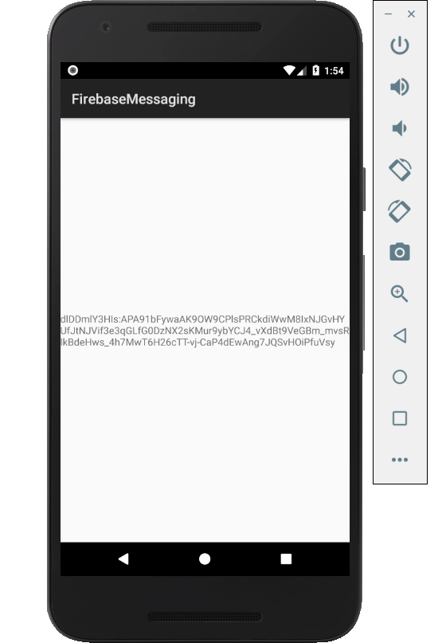

Figure 1. By Android Studio - https://developer.android.com/studio/, CC BY-SA 4.0, https://commons.wikimedia.org/w/index.php?curid=74094999

### 3.2.2 Image/firmware

Status

/1 Hardware present?

/1 Memo by student B + How did you make your Image/firmware? (500 words)

/1 Code can be run via serial or remote desktop

/1 Wireless connectivity

/1 Sensor/effector code on repository

### 3.2.3 Breadboard/Independent PCBs

Status

/1 Hardware present?

/1 Memo by student C + How did you make your hardware? (500 words)

/1 Sensor/effector 1 functional

/1 Sensor/effector 2 functional

/1 Sensor/effector 3 functional

The initial schematic design, Figure 2, based on datasheets (Bosch Sensortec, 2019) led to a breadboard layout Figure 3 that was realized Figure 4.

How did you build your Prototype: Breadboard?

Then a PCB was designed, Figure 5, and populated (Figure 6). Bill of Materials, Case, Time commitment. Testing. Progress.

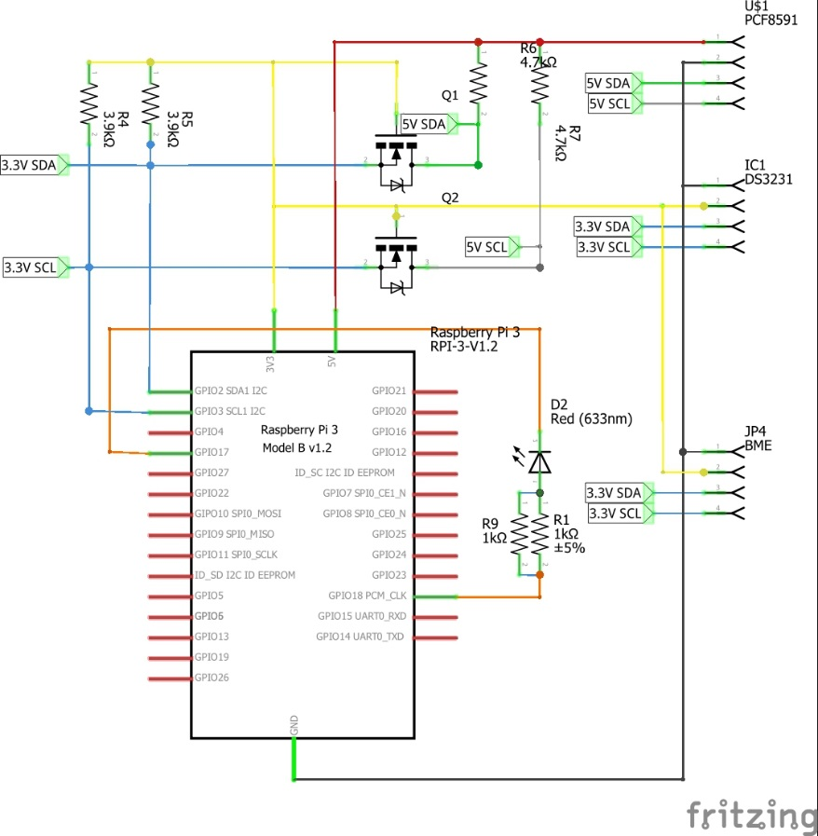

Figure 2. Initial schematic. This work is a derivative of "http://fritzing.org/parts/" by Fritzing, used under CC:BY-SA 3.0.

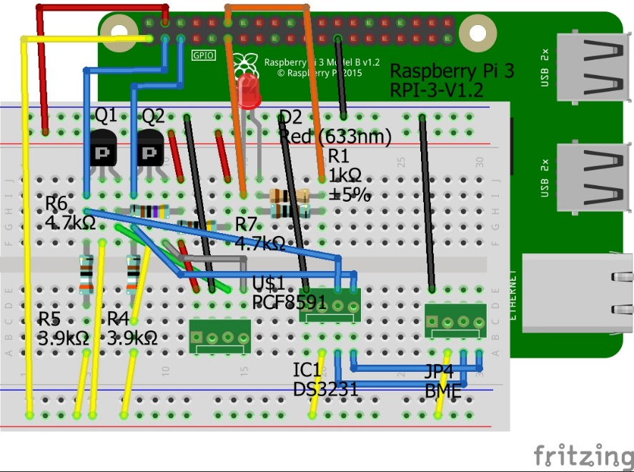

Figure 3. This work is a derivative of "http://fritzing.org/parts/" by Fritzing, used under CC:BY-SA 3.0.

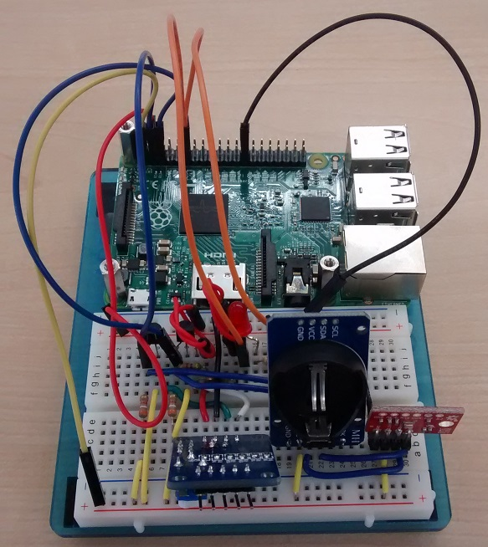

Figure 4. Breadboard prototype.

### 3.2.4 Printed Circuit Board

Demo

/1 Hardware present?

/1 PCB Complete and correct

/1 PCB Soldered wire visible but trim, no holes or vacancies

/1 PCB Tested with multimeter

/1 PCB Powered up

How did you build your Prototype: PCB?

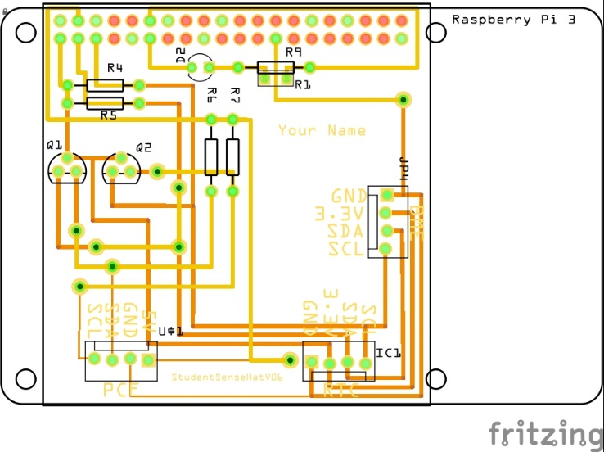

Figure 5. PCB design This work is a derivative of "http://fritzing.org/parts/" by Fritzing, used under CC:BY-SA 3.0.

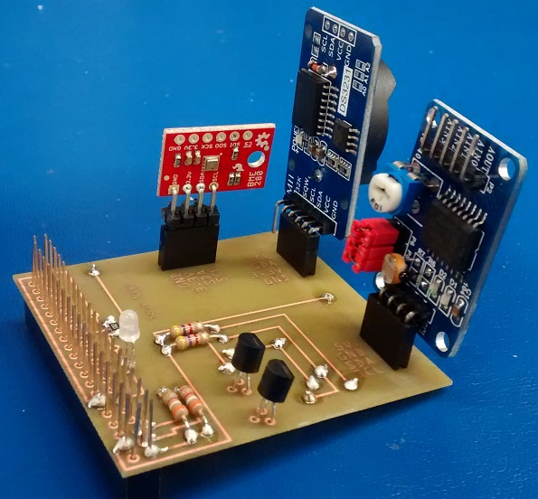

Figure 6. Humber Sense Hat Prototype PCB.

### 3.2.5 Enclosure

Demo

/1 Hardware present?

/1 Case encloses development platform and custom PCB.

/1 Appropriate parts securely attached.

/1 Appropriate parts accessible.

/1 Design file in repository, photo in report.

How did you build your Prototype: Case?

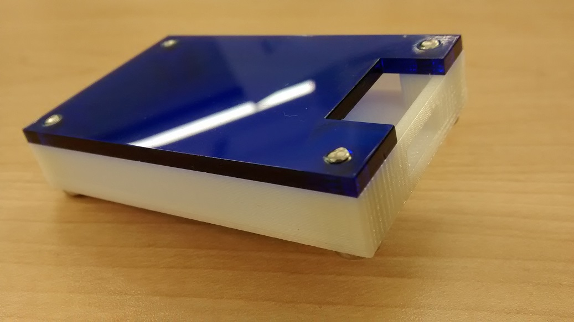

Figure . Example enclosure.

## 3.3 Integration

Demo

/1 Hardware present?

/1 Data sent by hardware

/1 Data retrieved by mobile application

/1 Action initiated by mobile application

/1 Action recieved by hardware

Report

/1 Enterprise wireless connectivity (250)

/1 Database configuration (250 words)

/1 Security considerations (500 words)

/1 Unit testing (900 words)

/1 Production testing (100 words)

### 3.3.1 Enterprise Wireless Connectivity

How did you make a Database accessible by both your Prototype and Mobile Application?

### 3.3.2 Database Configuration

### 3.3.3 Security

### 3.3.4 Testing

Unit testing and Production testing.

# 4.0 Results and Discussions

Is your prototype perfect? What did you learn?

# 5.0 Conclusions

If you were making 1000 of these.

Report

/1 Hardware present?

/1 Checklist truthful

/1 Valid Comments

/1 Results and Discussion (500 words)

/1 Conclusion

# 6.0 References

Bosch Sensortec. (2019, July). *BME680 - Datasheet.* Retrieved from Robert Bosch GmbH: https://ae-bst.resource.bosch.com/media/_tech/media/datasheets/BST-BME680-DS001.pdf

Kinsella, J. (2019). Five trends predicted for the cloud industry in 2019. *Software World*, 50(1), 11.

Media, O. (2019). *O'Reilly artificial intelligence conference 2019 - San Jose, California.* California: O'Reilly Media, Inc.

OACETT. (2017, March). *I need to Complete a Technology Report*. Retrieved from The Ontario Association of Certified Engineering Technicians and Technologists: https://www.oacett.org/Membership/Technology-Report-and-Seminar

Robuck, M. (2018, 11). AWS goes deep and wide with machine learning services and capabilities. *Fierceinstaller*.

# 7.0 Appendix

## 7.1 Firmware code

Demo

/1 Hardware present?

/3 Code runs concurrently for all sensors/effectors

/1 Project repository contains integrated code

Status

/1 Memo including updates

/1 Financial update

/1 Progress update

/1 Modified Code Files in Appendix

/1 Link to Complete Code in Repository

## 7.2 Application code

Demo

/1 Hardware present?

/1 Memo by student A

/1 Login activity

/1 Data visualization activity

/1 Action control activity

Report

/1 Login activity

/1 Data visualization activity

/1 Action control activity

/1 Modified Code Files in Appendix

/1 Link to Complete Code in Repository